Cardiac Diagnostic Services

EKG Entrance Examination – 2015

Technician Name: _____________________________ Date: ______________ Score: ______________

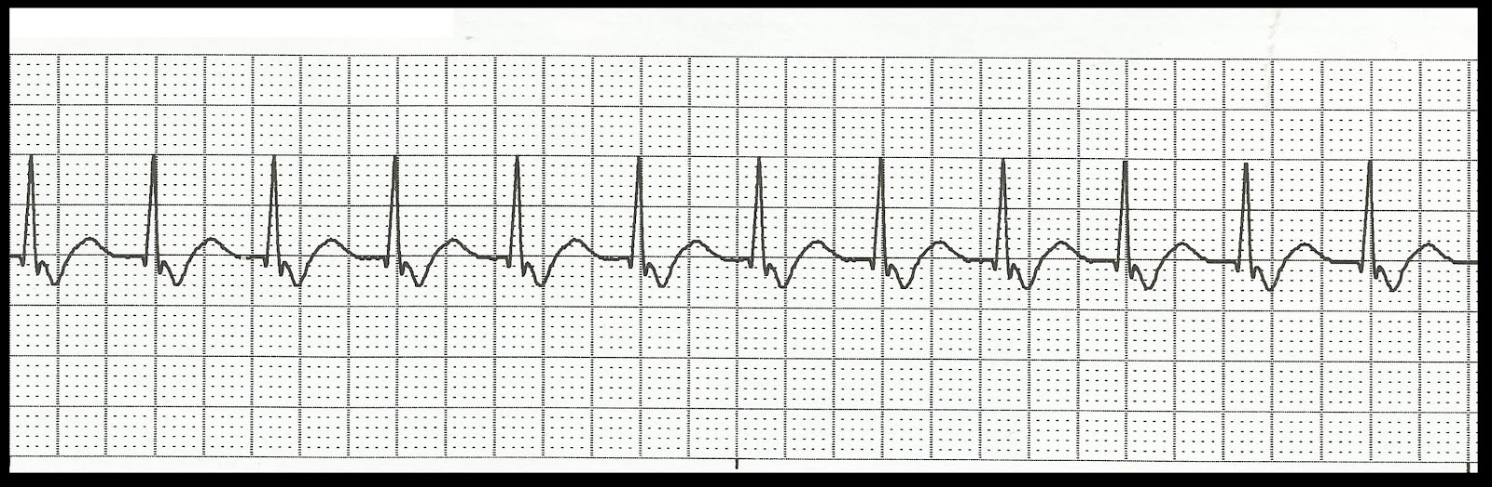

PR: ______________ QRS: _____________ QT: ______________ Rate: _____________

Interpretation: __________________________________________________________________________________________________________________________________________________________________________

[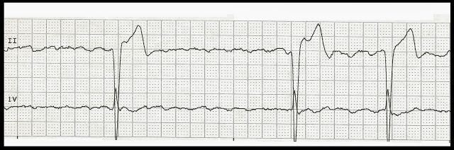](http://3.bp.blogspot.com/-YiS2lO8ng9c/UmPDE0_SwiI/AAAAAAAAWfo/rNg65o-Yn9M/s1600/Atrial+fibrillation+with+slow+ventricular+response.jpg)

PR: ______________ QRS: _____________ QT: ______________ Rate: _____________

Interpretation: __________________________________________________________________________________________________________________________________________________________________________

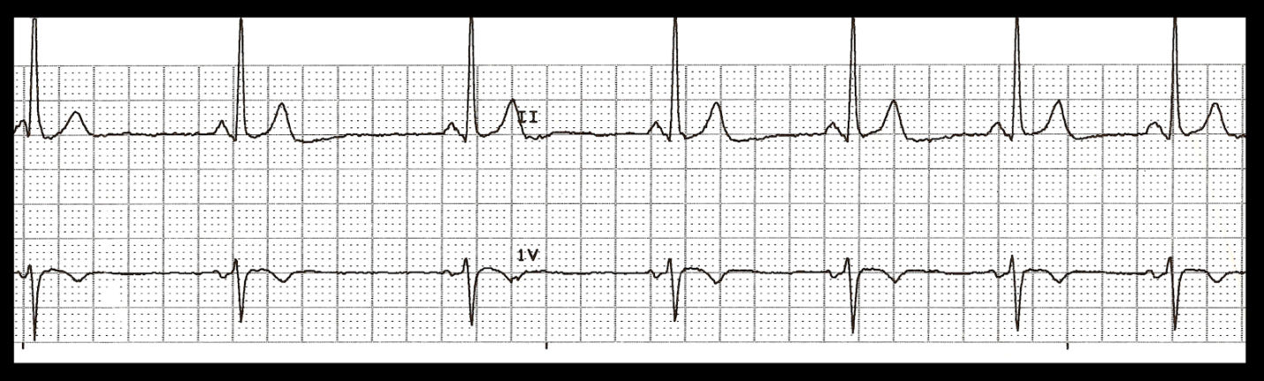

PR: ______________ QRS: _____________ QT: ______________ Rate: _____________

Interpretation: __________________________________________________________________________________________________________________________________________________________________________

[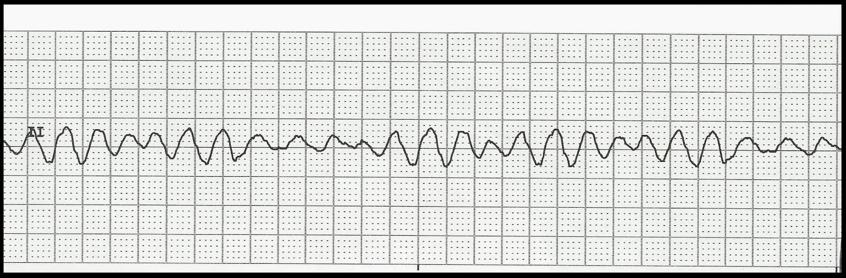](http://2.bp.blogspot.com/-cCL0HzG7ouI/Upkd5-HSlgI/AAAAAAAAXN4/yphQkFU5p_s/s1600/04+Ventricular+fibrillation.jpg)

PR: ______________ QRS: _____________ QT: ______________ Rate: _____________

Interpretation: __________________________________________________________________________________________________________________________________________________________________________

[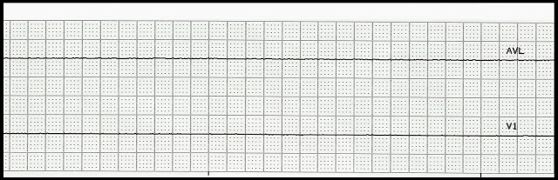](http://2.bp.blogspot.com/-diK4chxNRQ4/UpljL1rTtjI/AAAAAAAAXVI/Moir6OadDNQ/s1600/48++Asystole.jpg)

PR: ______________ QRS: _____________ QT: ______________ Rate: _____________

Interpretation: __________________________________________________________________________________________________________________________________________________________________________

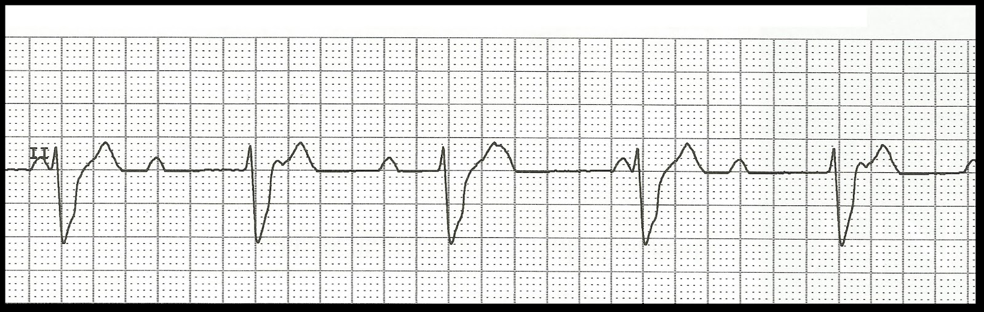

PR: ______________ QRS: _____________ QT: ______________ Rate: _____________

Interpretation: __________________________________________________________________________________________________________________________________________________________________________

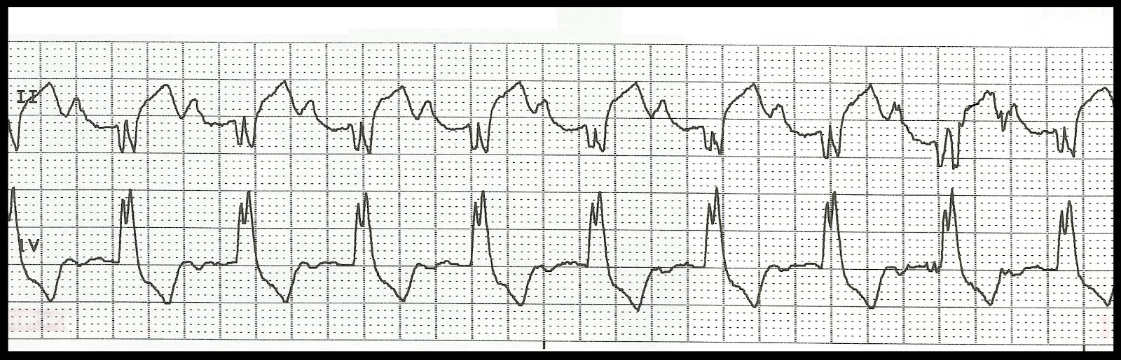

PR: ______________ QRS: _____________ QT: ______________ Rate: _____________

Interpretation: __________________________________________________________________________________________________________________________________________________________________________

[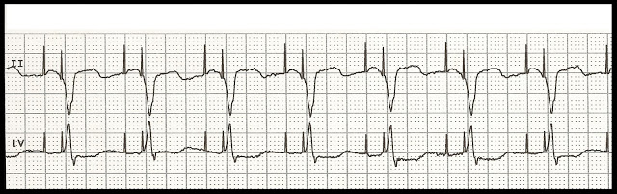](http://4.bp.blogspot.com/-sFOyu1CqOCM/UP2Eb5HuKMI/AAAAAAAAPB8/ta7DaUwuKFk/s1600/9+b+AV+paced.jpg)

PR: ______________ QRS: _____________ QT: ______________ Rate: _____________

Interpretation: __________________________________________________________________________________________________________________________________________________________________________

[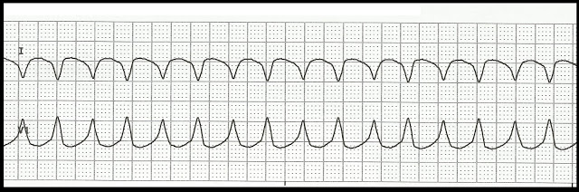](http://4.bp.blogspot.com/-XhoOYWRJ-uQ/UbOxGAPZm6I/AAAAAAAAUic/NheJxx2geYE/s1600/Ventricular+tachycardia+19.jpg)

PR: ______________ QRS: _____________ QT: ______________ Rate: _____________

Interpretation: __________________________________________________________________________________________________________________________________________________________________________

[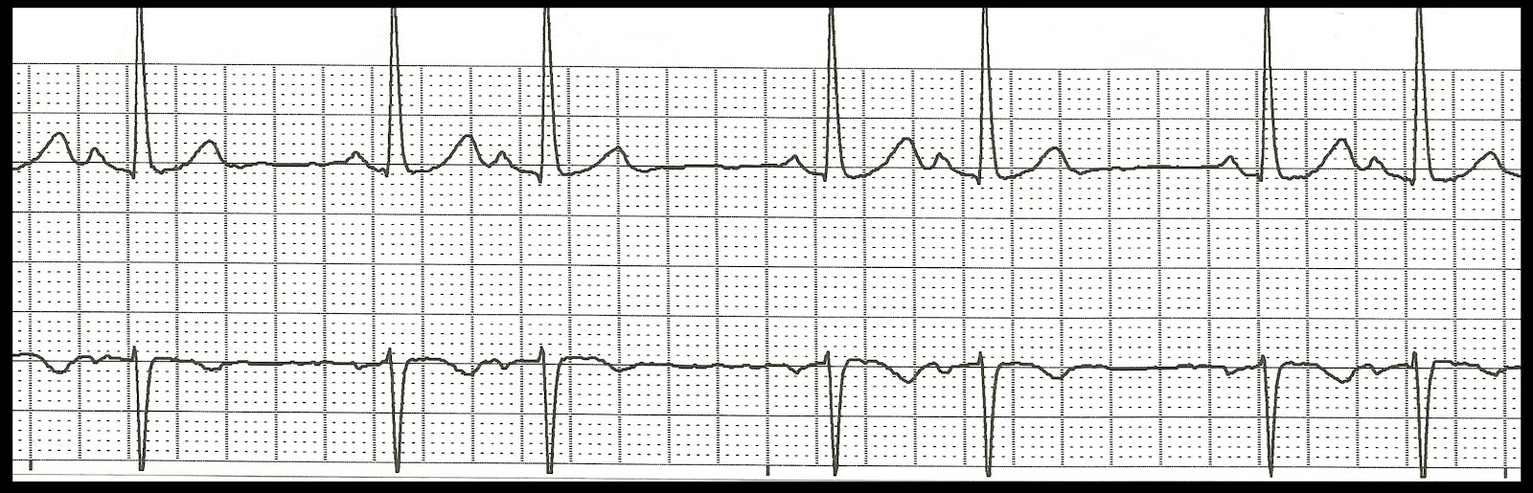](http://2.bp.blogspot.com/-aezyDiqRV9A/UVw82sVdtKI/AAAAAAAASCA/VO5V6gwkriA/s1600/NSR+with+PACs+01.jpg)

PR: ______________ QRS: _____________ QT: ______________ Rate: _____________

Interpretation: __________________________________________________________________________________________________________________________________________________________________________

[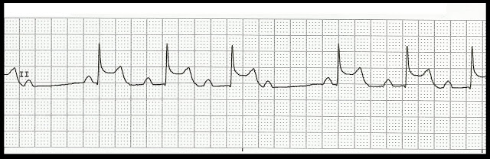](http://3.bp.blogspot.com/-yL94zdtse40/UZ9DvQu-FgI/AAAAAAAAT8c/Gd0Ks4qaUMg/s1600/2nd+degree+AV+block+type+I++15.jpg)

PR: ______________ QRS: _____________ QT: ______________ Rate: _____________

Interpretation: __________________________________________________________________________________________________________________________________________________________________________

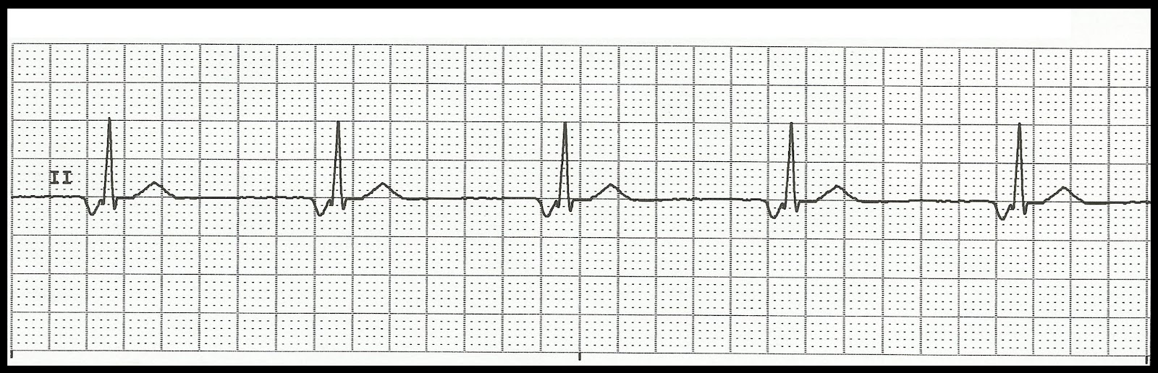

PR: ______________ QRS: _____________ QT: ______________ Rate: _____________

Interpretation: __________________________________________________________________________________________________________________________________________________________________________

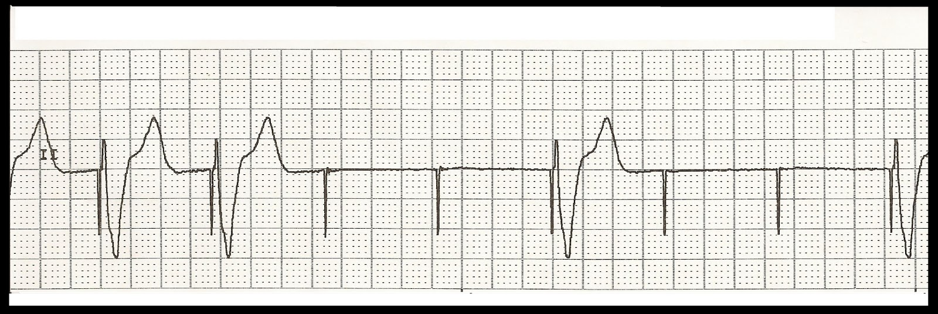

PR: ______________ QRS: _____________ QT: ______________ Rate: _____________

Interpretation: __________________________________________________________________________________________________________________________________________________________________________

[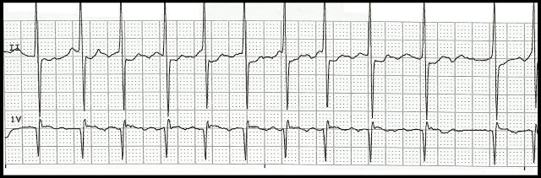](http://1.bp.blogspot.com/-rp4JKatTL-g/UV-LTuKUQUI/AAAAAAAASFU/-RAJWiTsjK8/s1600/Atrial+fibrillation+with+RVR.jpg)

PR: ______________ QRS: _____________ QT: ______________ Rate: _____________

Interpretation: __________________________________________________________________________________________________________________________________________________________________________

[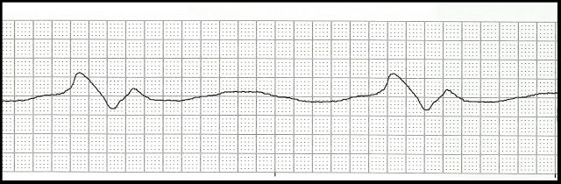](http://2.bp.blogspot.com/-zEOquFuuJX8/UPLofSfAvpI/AAAAAAAAOl4/IItLygDOVyA/s1600/Agonal+rhythm.jpg)

PR: ______________ QRS: _____________ QT: ______________ Rate: _____________

Interpretation: __________________________________________________________________________________________________________________________________________________________________________

[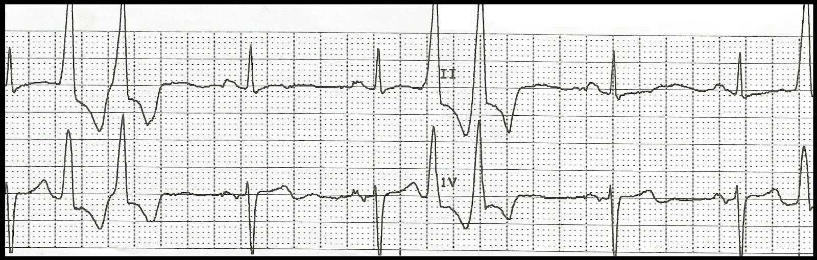](http://2.bp.blogspot.com/-ez1vE_lJJTk/UQesg5eIJtI/AAAAAAAAP2k/-fc4Y7L6cWc/s1600/NSR+with+multiple+couplets.jpg)

PR: ______________ QRS: _____________ QT: ______________ Rate: _____________

Interpretation: __________________________________________________________________________________________________________________________________________________________________________

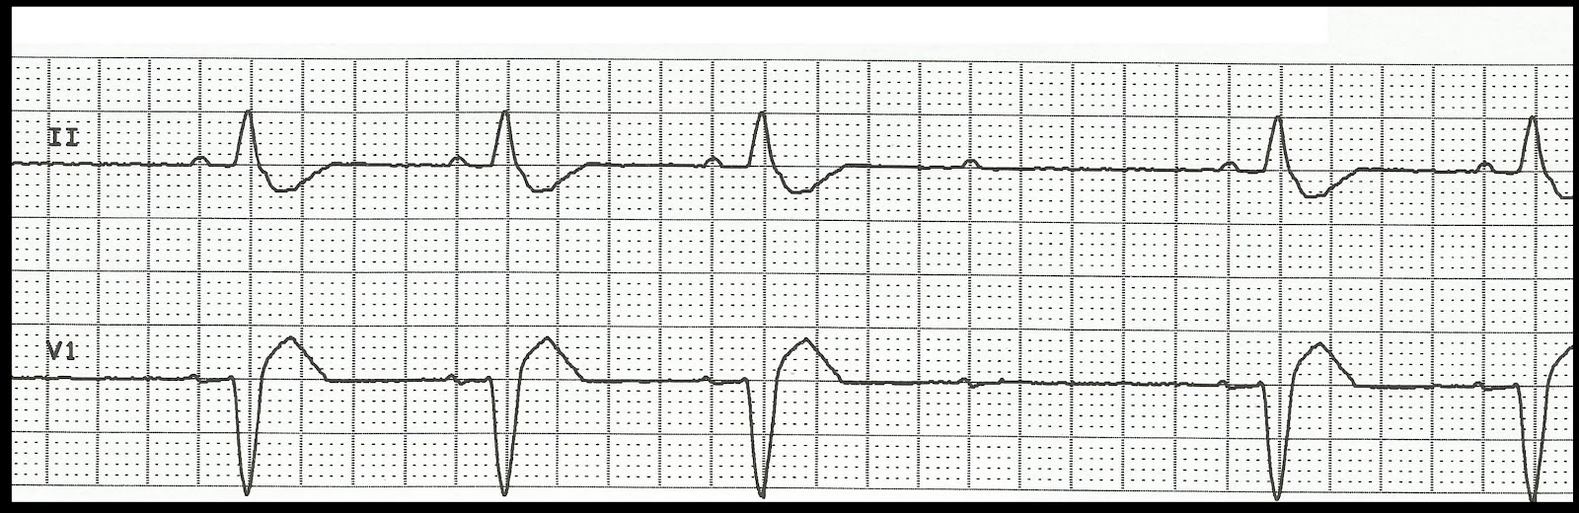

PR: ______________ QRS: _____________ QT: ______________ Rate: _____________

Interpretation: __________________________________________________________________________________________________________________________________________________________________________

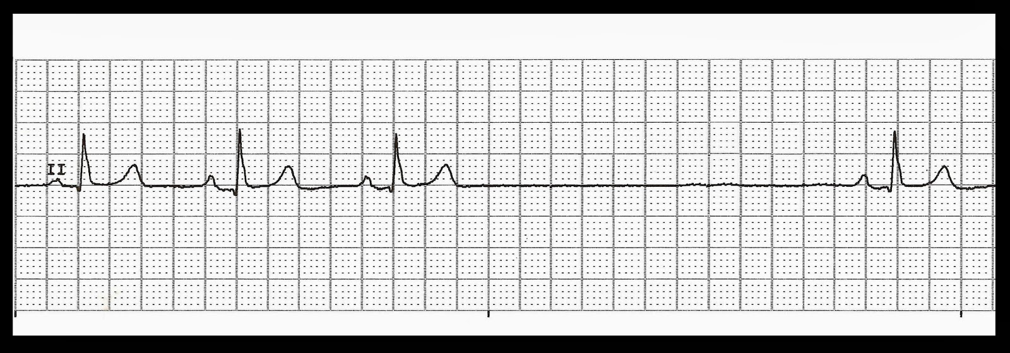

PR: ______________ QRS: _____________ QT: ______________ Rate: _____________

Interpretation: __________________________________________________________________________________________________________________________________________________________________________

[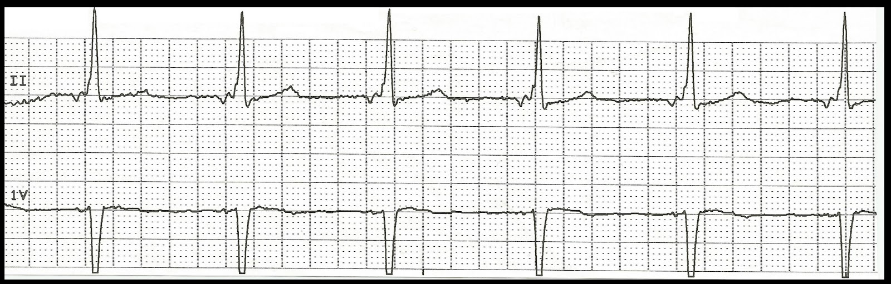](http://1.bp.blogspot.com/-2hFpgZGk37E/UXJ3zzXeTfI/AAAAAAAASrc/ng192wKMxJQ/s1600/Junctional+rhythm.jpg)

PR: ______________ QRS: _____________ QT: ______________ Rate: _____________

Interpretation: __________________________________________________________________________________________________________________________________________________________________________

[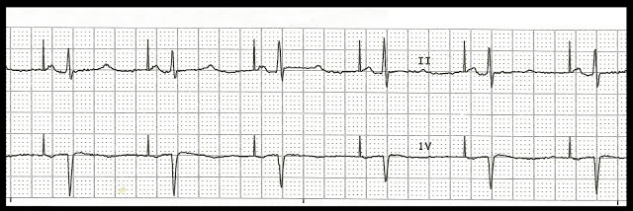](http://2.bp.blogspot.com/-sd9OmhQoaW8/UXfUIbFryLI/AAAAAAAAS24/QQGve5wFJFQ/s1600/Atrial+paced+05.jpg)

PR: ______________ QRS: _____________ QT: ______________ Rate: _____________

Interpretation: __________________________________________________________________________________________________________________________________________________________________________